Initial Post
by Kelly Kitching - Monday, 16 December 2024, 2:39 PM
Number of replies: 1
Designing metamodels offers several key strengths and weaknesses. According to Fortino et al. (2015), metamodels ensure that components clearly understand their behaviours and interactions, reducing confusion and facilitating smooth communication by abstracting key entities and their relationships.
Fortino et al. (2015) attempt to standardise metamodels but leave room for adaptability, particularly in areas such as security, which can be added later. However, adaptability remains a significant challenge, as Bashir et al. (2020) highlight, noting that each metamodel requires real-world validation, introducing additional costs and complexity. Real-world validation is essential to ensure the metamodel’s effectiveness and capture all relevant elements across diverse scenarios. Saleh (2023) further supports this, emphasising that while model comparisons can identify some gaps, key elements may still be overlooked depending on the context.
Fortino et al. (2015) acknowledge that metamodels enhance communication, which can, in turn, improve system uptime. Shah (2023) reinforces this point, noting that system uptime could improve by 10% to 15%. However, these improvements are often accompanied by trade-offs, such as increased maintenance complexity and additional costs, including redundancy. Balancing these trade-offs is crucial to ensure system reliability and efficiency, especially in IoT environments
Ultimately, while metamodels face challenges such as validation and maintenance complexity, they offer substantial advantages in system design, particularly when tailored and validated appropriately. Bashir et al. (2020) also highlight that metamodels support future users, making them beneficial not only for current system performance but also for future development and applications.
A metamodel for a humanoid robot
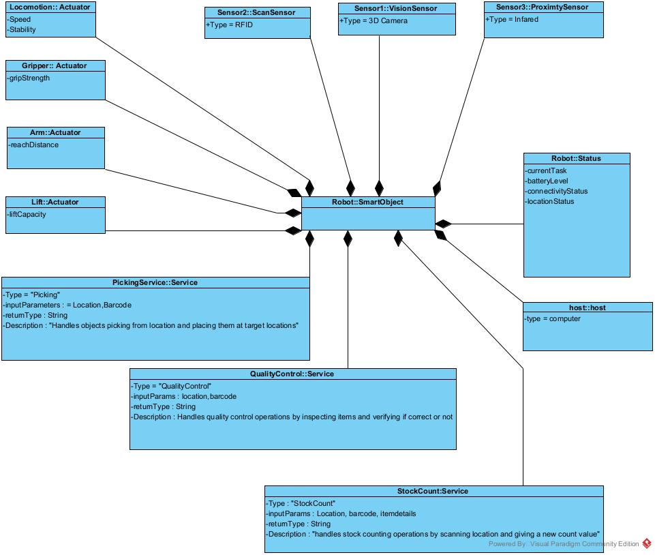

References
Bashir, M.R. et al., 2020. Big Data Management and Analytics Metamodel for IoT-Enabled Smart Buildings. IEEE Access, [e-journal] 8, pp.169740–169758. Available at: https://doi.org/10.1109/ACCESS.2020.3024066 [Accessed 16 Dec. 2024]
Fortino, G., Guerrieri, A., Russo, W. & Savaglio, C. (2015). Towards a Development Methodology for Smart Object-Oriented IoT Systems: A Metamodel Approach. 2015 IEEE International Conference on Systems, Man, and Cybernetics. 1297-1302. DOI: 10.1109/SMC.2015.231.
Saleh, M. et al., 2023. A Metamodeling Approach for IoT Forensic Investigation. Electronics, 12(3). Available at: https://doi.org/10.3390/electronics12030524 [Accessed 16 Dec. 2024]..
Shah, Q. A. et al. (2023) A Meta Modeling-Based Interoperability and Integration Testing Platform for IoT Systems. Sensors, 23(21). Available at: https://doi.org/10.3390/s23218730 (Accessed: 16 December 2024).

PermalinkReply

In reply to Kelly Kitching
Peer Response
by Todd Edge - Wednesday, 22 January 2025, 7:08 AM
Hi Kelly,
I was impressed with your analysis of IoT metamodeling; you draw upon useful sources that offer different perspectives on strengths and weaknesses of IoT metamodeling, and these are integrated well within your discussion.
I found Bashir et al. (2020) and Saleh (2023)’s suggestions particularly interesting, wherein it is commented that metamodels require real world testing in order to allow for a comprehensive design. As the financial costs and logistical complexities appear to be a barrier here (Bashir et al., 2020), I wonder if this could be addressed with an IoT simulation tool (equivalent to Pynsim - the Python Network Simulation - a versatile, object-oriented modelling framework that enables the processing of multi-disciplinary network simulations (Knox et al., 2018)). Such a tool could simulate IoT functionality, based on the data read within the metamodel, the results of which could inform metamodel redesign. This would save on time, financial costs, and avoid the logistical complexities that come real-world testing.
References
Bashir, M.R. et al., 2020. Big Data Management and Analytics Metamodel for IoT-Enabled Smart Buildings. IEEE Access, 8: 169740–169758. DOI: https://doi.org/10.1109/ACCESS.2020.3024066.
Knox, S., Meier, P., Yoon, J. & Harou, J. (2018) A python framework for multi-agent simulation of networked resource systems. Environmental Modelling & Software 103: 16-28. DOI: 10.1016/j.envsoft.2018.01.019.
Saleh, M. et al., 2023. A Metamodeling Approach for IoT Forensic Investigation. Electronics, 12(3): 524-562. DOI: https://doi.org/10.3390/electronics12030524.
In reply to Todd Edge
Re: Peer Response
by Todd Edge - Saturday, 25 January 2025, 6:50 AM
Hi Kelly,
After returning to Fortino et al.'s (2015) article, I realised that they do discuss how ELDASim provides simulated validation for their metamodels (after the ELDA model is translated into Java code); this goes some way to addressing your point about costs of real-world validation, however, the more rigorous the testing, the more reliable the software, and so this does not to deny that real-world testing is an important validation process. It could, however, reduce the number of tests needed and thus reduce time and financial costs.
Todd
References
Fortino, G., Guerrieri, A., Russo, W. & Savaglio, C. (2015). Towards a Development Methodology for Smart Object-Oriented IoT Systems: A Metamodel Approach. 2015 IEEE International Conference on Systems, Man, and Cybernetics. 1297-1302. DOI: 10.1109/SMC.2015.231.

In reply to Timothy Brayshaw
Peer response
by Todd Edge - Saturday, 25 January 2025, 7:04 AM
Hi Tim,
I enjoyed reading your well-structured review of Fortino et al.'s (2015) metamodel approach to IoT design.
You highlight key strengths, such as the metamodel's ability to provide consistency through development stages and various levels of abstraction (Fortino et al., 2015). I wondered though whether the complex nature of developing metamodels at different levels of abstraction could be revised in future iterations of this metamodel, with the development of fewer metamodels - or even just one - that could account for all stages of smart object development.
I also think it is important to highlight Fortino et al.'s (2015) acknowledgment that their metamodel does not address security, as this is such an important area of IoT device development (Meneghello et al., 2019).
Kind regards,
Todd

References

Fortino, G., Guerrieri, A., Russo, W. & Savaglio, C. (2015). Towards a Development Methodology for Smart Object-Oriented IoT Systems: A Metamodel Approach. 2015 IEEE International Conference on Systems, Man, and Cybernetics. 1297-1302. DOI: 10.1109/SMC.2015.231.

Meneghello, F., Calore, M., Zucchetto, D., Polese, M., and Zanella, A. (2019) ‘IoT: Internet of Threats? A Survey of Practical Security Vulnerabilities in Real IoT Devices’, IEEE Internet of Things Journal. 6(5): 8182-8201. DOI: https://doi.org/10.1109/JIOT.2019.2935189

